The Students performance in Exam dataset contains 1000 records. It includes 8 variables: gender, race.ethnicity, parental.level.of.education, lunch, test.preparation.course, math.score, reading.score, writing.score. 5 columns contain categorical data and 3 contain numerical data.

Variable | Mean | Median | Standard Deviation
Math.score | 66.1 | 66 | 15.16
reading. score | 69.17 | 70 | 14.60
writing. score | 68.05 | 69 | 15.2

Figure 1. Mean, Median and Mode of math, reading, and writing scores

Based on the descriptive statistics, the math.score variable has a mean of 66.1, a median of 66, and a standard deviation of 15.16, indicating the distribution and variability of the scores. The reading.score variable has a mean of 69.17, a median of 70, and a standard deviation of 14.60. Lastly the writing.score variable has a mean of 68.05, a median of 69, and a standard deviation of 15.2, describing the central tendency and spread of the data.

Variable | IQR | Upper fence | Lower fence | Outliers
math. score | 20 | 27 | 107 | 8
reading. score | 20 | 27 | 107 | 5
writing. score | 21.25 | 25.125 | 108.875 | 5
Figure 2. IQR and Outliers of math, reading, and writing scores

Based on the computed Interquartile Range (IQR), as well as the lower fence and upper fence values for each column, several outliers were detected in the dataset. The math.score has 8 outliers, while the reading.score and writing.score columns have 5 outliers. These outliers are considered as insignificant data, because they fall below the lower fence or exceed the upper fence, indicating values that are unusually low or high compared to the majority of the data.

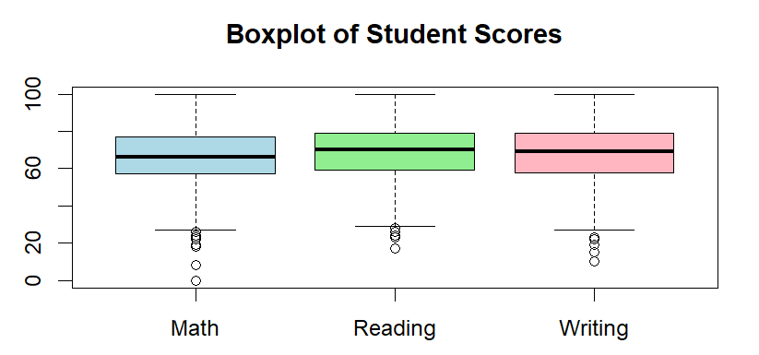
Figure 3. Boxplot Chart of math, reading, and writing scores
The boxplot illustrates the distribution of student scores in Math, Reading, and Writing, showing the median, quartiles, range, and potential outliers. The boxes represent the middle 50% of the scores, with the line inside each box indicating the median score, while the whiskers show the spread of most scores within 1.5 times the interquartile range. A few dots below the whiskers indicate low outliers, meaning some students scored significantly lower than the majority. Overall, the plot shows that students generally performed similarly across the three subjects, with most scores falling between approximately 60 and 80, and the median scores for all three subjects are fairly close, suggesting consistent performance with a few students scoring much lower than their peers.
